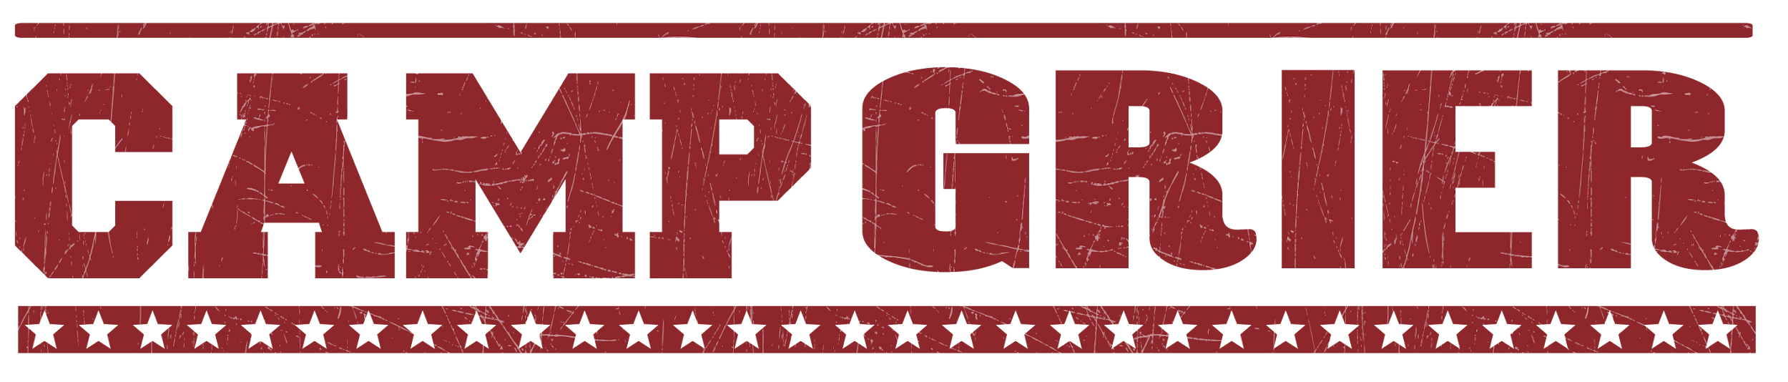
CAMPER PACKING LIST
Please do NOT bring:
Candy or Gum
Food
Weapons of any kind
Non-prescription drugs
- Daypack (bookbag)
- Flashlight or headlamp
- BUG SPRAY!!!
- Sunscreen
- 2 Water Bottles
- Bedding
  - Sleeping Bag
  - Blanket/Sheets for single bed
  - Pillow
- Laundry bag
- Toiletries
  - 2-3 Towels
  - Washcloth
  - Toothbrush, toothpaste, etc.
  - Soap, shampoo, etc .
  - Deodorant
- Pajamas
- Outdoor clothes that are comfortable and can get dirty!
  - Quick dry shirts, t-shirts, tanks
  - Shorts
  - Pants
  - Appropriate Swimwear
  - Sweater and/or warm jacket (it can get chilly in the evenings)
  - Rain gear (Rain jacket or poncho)
  - Baseball hat, possibly a winter hat
- Footwear
  - Tennis shoes
  - Water shoes that can get wet (must have a backstrap)
  - Sturdy hiking shoes
  - Socks (can never have too many) including a heavy pair for hiking
  - Shower shoes (Flip flops are not allowed outside of the cabin)
- Stationary & Stamps for those who love writing letters!
- Journal, pen and pencil
- Optional: Hammocks
Costumes/accessories for Rustic Dance (Adventurer & Navigator)
Small Fan (if battery powered, bring extra batteries)

Specialty camps:
We provide bikes and helmets (both for MTB and equestrian).
You are welcome to bring your own if you prefer.

Mountain Bike specialty list:
Camp Grier has a fleet of full suspension bikes and all necessary equipment for campers to use. Campers are welcome to bring personal riding gear if they prefer.
- Tech shirts
- Bike water bottle
- Helmet
- Bike
- Hydration pack
- Riding gloves

Equestrian specialty list:
- Long pants or jeans (preferably cotton or a material that provides some grip)
- Long socks
- Boots or shoes with a heel (sturdy and water resistant if possible)
- Bug spray!!!
- Riding helmet (we provide helmets, however sizes may be limited)

